RNN:
RNN is used for sequential data.
RNN is not usually used for sequential data due to two major problems and the need for LSTM arised.

PROBLEMS:
- Problem of long term dependency
- STAGNATED TRAINING (RNN ko properly train na kr pana)

Long term dependency:
Iska mtlb hai ky agar data point ki length bht bari hai like 10,000, so 10,000 timesteps create hon gy to jo word 9000 step pr hai wo us word ko bhoolny lagay ga jo 1st timestep pr hai, yani ky memory loss.

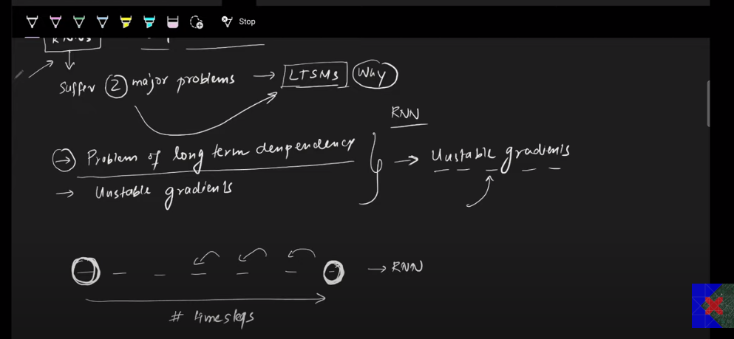

Jab hamaray RNN mn timesteps (words in a data point) bht zyada barh jaty hain to last waly word ki prediction mn first walay words ka contribution bht kam ho jata hai kyn ky activation function tanh hota hai jo 0-1 ky darmaya hota hai. Isi trhan past words ka gradient reduce hota chala jata hai or recent words ka weightage word ko predict krny mn barh jata hai. Jis sy RNN long term dependency capture nhi kr pata.

How can we reduce long term dependency problem (maybe):
- Use different activation function
- Better weight initialization technique
- Skip RNN
- Let’s move to LSTM

Unstable training:
Exploding gradient can occure, iska mtlb hai ky farz karo ham relu activation function use krty hain, to last waly words ka gradient itna zyada barh jata hai ky rcent words ka weightage ignore ho jata hai
How can we solve this problem:
- Gradient Clipping (limit laga do ky gradient is sy oper jana hi nhi chahiye)
- Controlled learning rate
- Move to LSTM

